**Invitation for an annual health check and health action plan**

**Dear…………………………….,**



Please make an appointment with your GP practice.

Date:

Practice:



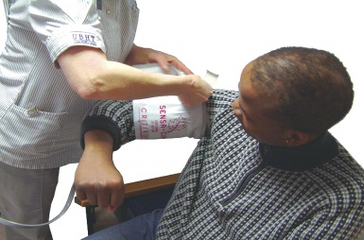

The health check is important to make sure that you are healthy and that you are getting the right help.



You can bring someone with you.

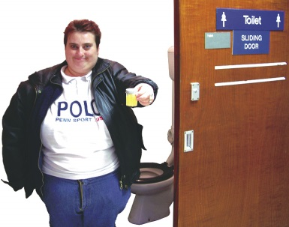

Please make sure that you bring an urine sample to the appointment.

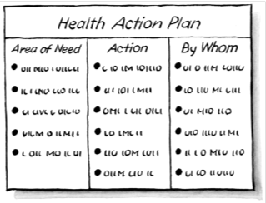

At the end of the appointment, a Health Action plan will be completed with you and a copy will be given to you.

[](https://www.google.co.uk/url?url=https://www.123rf.com/stock-photo/telephone_cartoon.html&rct=j&frm=1&q=&esrc=s&sa=U&ved=0ahUKEwj9tcrz7ZrMAhUMnBoKHSPgD-cQwW4INjAQ&usg=AFQjCNHj9BRbst7b4bvJP5RmWE-5yBbcqw)

To make an appointment call this number:

XXXXXXXXXXXXXXXXX

Thank you. We look forward to seeing you soon.

[](http://www.google.co.uk/url?url=http://keeb.com/?page_id=412&rct=j&frm=1&q=&esrc=s&sa=U&ved=0ahUKEwjsq_X88JrMAhUGCBoKHYzBBzUQwW4IFjAA&usg=AFQjCNH5FcbzPAYqhfnUN26ClYzo8h4Vvg)

From ………………………………………………………………….