Learning Disabilities

https://www.england.nhs.uk/wp-content/uploads/2017/05/nat-elec-health-check-ld-clinical-template.pdf
This document provides a content summary and overview of the new National Electronic Health Check template for people with learning disabilities, agreed as part of the GP contract initiated from April 2017. The National Electronic Health Check clinical template for people with learning disabilities is to be made available to GP Practices through their GP IT system provider; work is underway to facilitate such. The template offers GPs a systematic approach to the Health Check which is code based, drawing on the existing patient record. This means that the structure of the template (dependant on IT system) can adjust according to the individual patient, for example screening questions will be gender and age appropriate and will only appear for eligible patients; similarly immunisations will be drawn from the existing record whereby current requirements can be determined.
This is now available from Emis Library
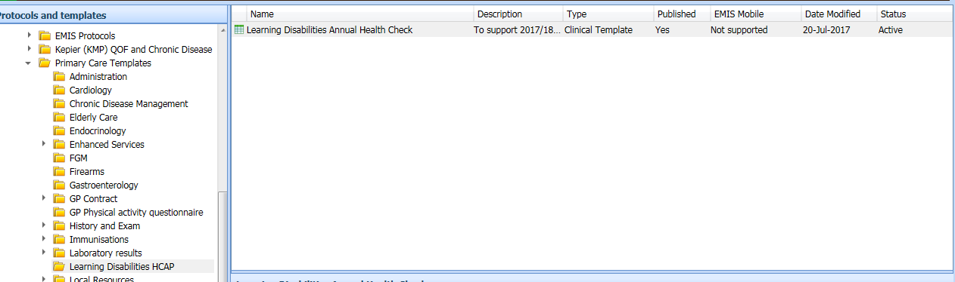

A protocol to flag patients needing review is also available from Emis Library
