SPH
Somerset GP Board

Dear Colleagues

New Chief officer at Somerset CCG

At our regular LMC/CCG liaison meeting yesterday, we had our first substantive discussion with Nick Robinson, the new CCG Chief Officer. He was candid about what had and hadn’t worked well in the Somerset healthcare system in recent years, and appears to share many of our concerns about the over-complicated STP processes and how it all fits together, or perhaps doesn't.

He appeared to understand our frustrations, and to have the drive and determination to tackle some of the recurrent problems head-on. Clearly the LMC will be watching what happens very closely, but it struck me again yesterday whilst talking with him that this does feel exactly the right time for us to have formed Team GP (more formally the Somerset GP Board).

Communication is absolutely fundamental here, and we established yesterday that there will be a GP meeting- probably towards the end of October, so he can discuss his views/thoughts/plans with as many GP colleagues as possible. He also indicated that back-fill will be provided, as he recognises the importance of getting as many GPs there as possible. Hopefully we'll get a date established in the next few days, and will let you know as soon as we are able to do so.

Best wishes

Yours Sincerely

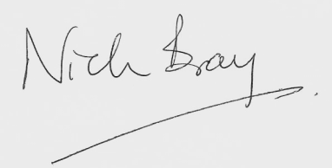
Dr Nick Bray
Somerset LMC Chairman

C/O Somerset Local Medical Committee Crown Medical Centre
Venture Way Taunton
TA2 8QY

Chairman: Dr Nick Bray
Vice Chairman: Dr Sue Roberts

Email: LMCoffice@somersetlmc.nhs.uk
Phone: 01823 331428 Fax: 01823 338561

