This statement is an update for GPs on the issue of TPP’s SystmOne and the DPA. As Representatives of the British Medical Association and the Royal College of GPs we have been working closely with NHS England, NHS Digital, TPP and their user group to address our concerns regarding the ability of GP data controllers using SystmOne to comply with the DPA.

We are now at a point where the BMA and RCGP believe that new functionality developed by TPP, when finalised and fully implemented, will allow GP Data Controllers to meet their obligations under the DPA. We expect these tools to be available to all GPs using SystmOne by the end of February 2018.

This new functionality is currently being piloted and we are continuing to monitor progress.

We continue to keep the ICO informed and involved as necessary and they remain supportive of the actions and plans to date.

Signed:

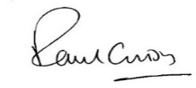
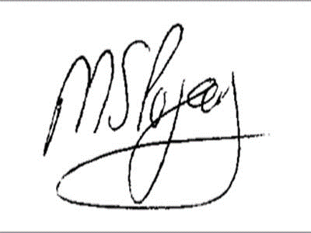

Dr Paul Cundy  GPC Co-Chair of the Joint GP IT Committee | Dr Manpreet Pujara  RCGP Co-Chair of the Joint GP IT Committee

