CD1 form/Gold Sheet 2018 – guide to changes (side 1)
Suggested time between doses is reduced but with a safety net of when to seek advice for patients who require repeated doses.
These are starting doses for patients who have not required anticipatory medications before. Patients on higher strength opioids or syringe drivers will need different prescriptions.

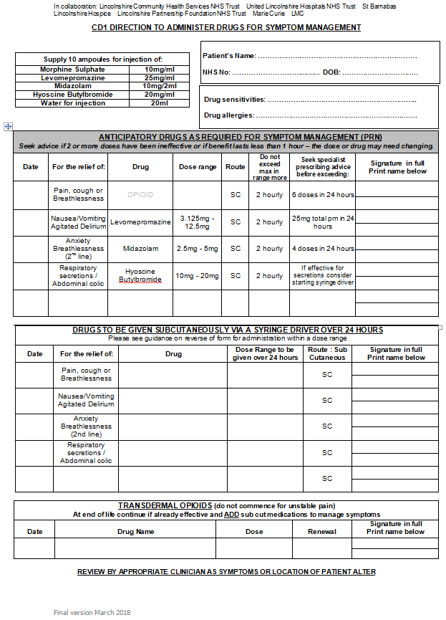
CAUTION:
The order of the tables has changed to reflect the usual order of medication use.
Prescribing should be individualised to the patient.
These are common medications and doses that treat the most common symptoms in patients for comfort care.
This can be changed to reflect your local preferences, or patient wishes and needs.

CD1 form/Gold Sheet 2018 – guide to changes (side 2)
Morphine is now recommended first line in opioid naïve patients as it has equivalent efficacy and is cheaper.
CAUTION:
Diamorphine is more potent than morphine.
This guidance is the same as Lincolnshire Guidelines: Symptom Management in Adult Palliative and End of Life Care(available on www.EOLC.co.uk).

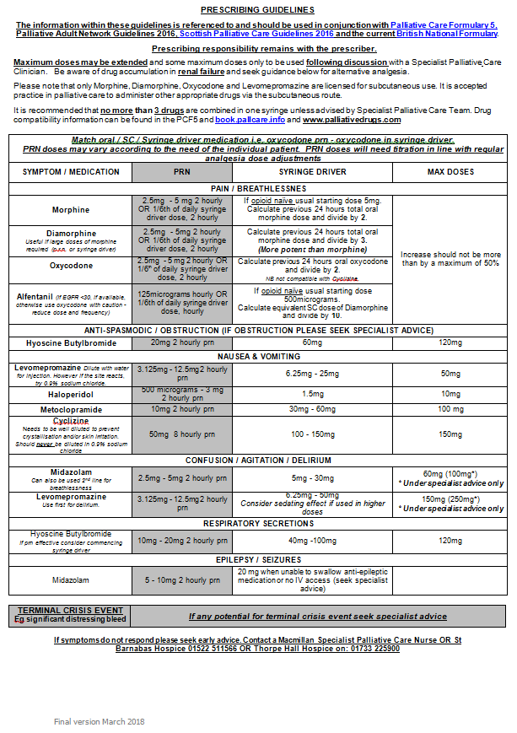
Please print onto yellow/gold paper.
If this is unavailable, professionals can work together to ensure that it stands out in the paperwork in the patient’s home.
Alfentanil injection now has Amber2 status in the Lincolnshire Formulary (use with specialist advice). It is recommended for patients with severe renal failure.

