Oxfordshire  Clinical Commissioning Group | Chief Executives Dr Matt Mayer & Dr Richard Wood  Chair Dr Simon Ruffle

FAO: All Oxfordshire GP Practices
September 2019

Post-Exposure Prophylaxis: Memorandum of Understanding

From time to time a Public Health England official may ask a GP to prescribe prophylaxis treatment to exposed cases of a disease. Examples might include patients exposed to, but not yet suffering from, group A streptococcal infection, infectious meningitis, or Hepatitis A, though there are others. As this is outside of core GMS work, locally commissioned arrangements are typically created to carry this out. Flu prophylaxis is one such example for which there is an LCS.
The incidence of non-flu post-exposure prophylaxis requests is comparatively small and therefore does not warrant the time invested in creating a dedicated LCS. Rather, the OCCG and LMC have reached an agreement for a memorandum of understanding by which practices will be reimbursed for this work if requested from Public Health England (PHE). If the practice is asked to do prophylactic prescribing for exposure cases and agrees to do so, then they can invoice the OCCG for payment.
This MOU is operational under the following specifications:
- It will apply to prescribing of post-exposure prophylaxis that has been directly requested by a Public Heath England official. It does not cover requests from other agents, such as specialists in secondary care.

- The fee for the work is set by the practice. The current tariff for the flu prophylaxis LCS (£30) may be referenced as a guideline for establishing cost. Fees significantly above that level should be discussed with the CCG in a timely manner, ideally prior to to commencing the work if that is feasible.

- The OCCG contact for invoicing and discussion is Ms Rachel Jeacock: RachelJeacock@nhs.net, 01865 XXX XXX.

The OCCG and LMC jointly encourage practices to make use of this MOU for safeguarding the health of our patients.

[signature]  Mrs Julie Dandridge  Primary Care Manager  Oxfordshire Clinical Commissioning Group  Jubilee House | 5510 John Smith Drive  Oxford Business Park South  Oxford OX4  Email: julie.dandridge@nhs.net | 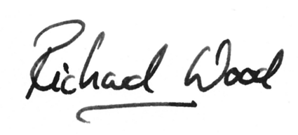  Dr Richard Wood  CEO – Berkshire, Buckinghamshire & Oxfordshire LMC  Mere House, Dedmere Road, Marlow, Buckinghamshire, SL7 1PB  Tel: 01628 475727 – Fax: 01628 487142 – Mob: 07980 817 551. Web: www.bbolmc.co.uk  Email: ceo@bbolmc.co.uk or Richard.Wood@bbolmc.co.uk

