The Secretariat of the Local Medical Committees for
Berkshire, Buckinghamshire & Oxfordshire
Mere House, Dedmere Rd, Marlow, SL7 1PB
Tel: 01628 475727
Fax: 01628 487142
Chief Executives Dr Matt Mayer & Dr Richard Wood
Chair Dr Simon Ruffle
Web: http://www.bbolmc.co.uk
Email: ceo@bbolmc.co.uk

October 2019

Dear Practices,

Re: Changes to the Statutory (local) LMC Levy

On Tuesday, 30th July 2019 the Board of BBOLMCs resolved to increase the LMC levy effective from 1st January 2020. This communication explains the background to the decision, the reasons for the change and what it will mean for you going forward.

What is the levy?

All LMCs across England are cited through various and successive Acts of Parliament as the statutory bodies who represent the interests of General Practice. Those statutes allow LMCs to “levy” a fee for their services from practices. This is deducted at source, meaning whilst it will not appear in your accounts it will be shown on your Open Exeter statements. This is called the “statutory” levy.

Also, the LMC sends a portion of the levy to the General Practitioners Defence Fund (GPDF) to fund things such as national representation, GMS contract negotiations, UK & England LMC Conference and any legal action which is taken nationally on behalf of General Practice. This is called the “voluntary” levy.

Currently, our statutory levy mandate is set to 35p, from which the voluntary levy is set by GPDF at 6p per patient, meaning BBOLMCs has a maximum of 29p per patient of funding for all our services. In actual fact, the Treasurers are only pulling down an average of 24p per patient (or 30p including the GPDF voluntary levy).

When was the levy last increased?

The levy was last increased approximately 16 years ago, before the introduction of the 2004 GMS Contract. When we consider that the levy has not been increased with inflation, yet Global Sum and population have, this means BBOLMC is 30% less funded than it was back in 2004 in real terms. All LMCs we spoke to review their levy every couple of years.

Why does the levy need to be increased?

Over the past 6 months, the Chief Executives have presented a comprehensive 5-year plan to the Board for the future of BBOLMCs in order to improve services to constituents and maximise GP working conditions and pay. This has involved surveys to you as constituents, discussions with other LMCs around England and scrutiny of the records of the BBOLMC organisation over the past 20 years.

It has become apparent that the level of service offered by BBOLMC falls somewhat short of levels of service offered to constituents of other LMCs across the country. BBOLMC is the fourth largest LMC in the UK in terms of patient population, yet we have less Secretariat staff per constituent than many LMCs who are much smaller than us (in fact, 1.6 WTE of constituent-facing staff to cover a population of approximately 2.1 million patients). Similarly, of the 30 LMCs we have met/discussed with, our levy is by far the lowest of all of them. Compared to our average drawn down levy of 24p, the national average is closer to 43p (or 49p including the GPDF voluntary levy).

How much will the levy go up by?

Currently, our mandate is set to 35p – This is the maximum we can draw down, including the GPDF levy of 6p. The Board has resolved to increase the mandate to 45p. However, it is important to note that the Board is not proposing drawing down that maximum. We anticipate that the maximum drawn down will only be approximately 37p in the first couple of years. This change in mandate is to allow us to gradually increase our funding and services over the next 5 years. Furthermore, this increase after a long period of no increase will mean we will not need to increase the mandate again for several years. This increase to a maximum of 45p would bring your LMC to just under the figure we would currently be on if the levy had increased with global sum.

What will the extra levy be used for?

Currently the LMC is staffed by a comparatively very small Secretariat which consists of two Chief Executives working a total of 12 sessions combined, a Medical Director working 4 sessions who only covers Berkshire, and two full time admin staff. Despite those staff working well over and above their contracted hours, there is a significant unmet need. The proposed changes to the structure and function of the LMC have been fully costed and fit within the proposed change in funding envelope. Those services which we plan to introduce include:

- Two additional Medical Directors (4 sessions each) – For Buckinghamshire & Oxfordshire
- A non-Medical Director (6 sessions) – To provide advice to Practices across all 3 counties, particularly providing support to practice managers
- A subsequent increasing of resource to make sure General Practice is appropriately represented at high level where significant changes to health service delivery across BBO are afoot
- A legal retainer with a leading law firm to provide legal support/advice to the Secretariat
- Increased admin hours to extend office opening hours and capacity
- Admin staff attendance at committee meetings for minute taking
- New website with improved resources for constituents
- Training events for constituents and Practice Managers

The Chief Executives and Board believe strongly that we now have the plans and proposals in place to improve the level of service you receive from BBOLMCs and would be grateful for the support of practices in taking this forward.

In order to enact this change, we require all practices who are members of the LMC to sign the attached mandate form which will enable NHSE to make the appropriate deductions.

If you have any questions, concerns or need any clarification about the above do not hesitate to contact the LMC at ceo@bbolmc.co.uk

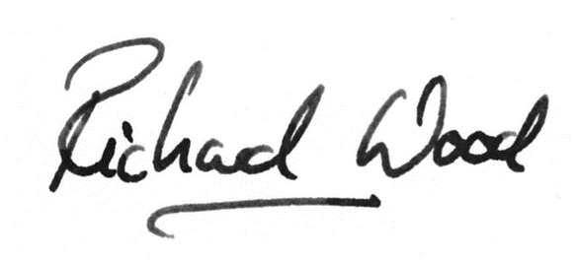
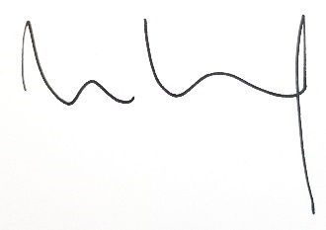

Dr. Simon Ruffle Dr. Matt Mayer Dr. Richard Wood
Chair of Board, BBOLMCs Chief Executive Chief Executive
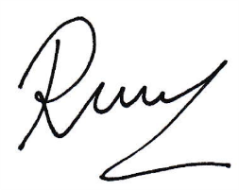
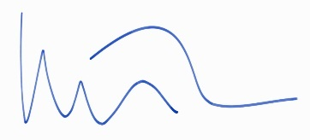
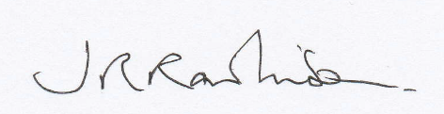

Dr. John Rawlinson Dr. Stefan Kuetter Dr. Raman Nijjar
Chair, Berkshire LMC Chair, Buckinghamshire LMC Chair, Oxfordshire LMC

