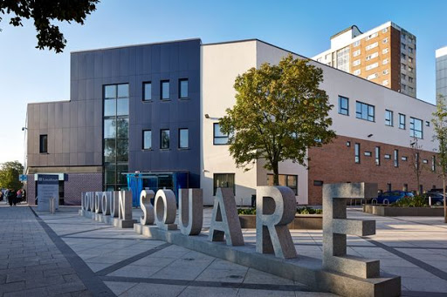
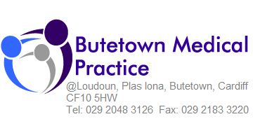
Salaried GP
(Full /Part time or hours to suit)
Work to live not live to work!

We have an excellent opportunity for you to join our thriving practice as a salaried GP. We have an excellent team, who are always looking for ways to work innovatively and maintain our ethos of “Work to live not live to work”.
With a diverse population, we are incredibly passionate about the work we do with homeless, substance misusers and other vulnerable groups. Although this work can be challenging it is extremely rewarding and we are keen to recruit like-minded GPs who share our vision.
Our focus is on a good supportive team atmosphere and excellent patient care and we are flexible to allow work hours fit around you and your schedule. We offer the following benefits;
- Full induction and support
- 6 weeks leave plus 1-week study leave (pro rata)
- Competitive salary (Negotiable)
- Option for partnership by mutual agreement
- Works collaboratively within a likeminded cluster, sharing ideas and resources
- Special interests homeless and substance misuse and vulnerable groups
- Streamlined admin workflow to reduce the GP administrative workload
- Extremely low house call visits for GPs with paramedics carrying out the bulk of visits
“Butetown Medical Practice”
Our purpose built premises are leased from the Local Health Board and located in the Cardiff Bay area formerly known as Tiger Bay. Cardiff Bay is described as one of the most successful redevelopment projects in the UK with Europe’s largest Waterfront development. Cardiff Bay has been transformed into the flourishing, vibrant, friendly and trendy part of Cardiff that it is today. It has excellent sports, leisure facilities, and transport links to the city, Penarth, and Vale of Glamorgan.

The Practice area also covers the traditional multi-cultural communities of Butetown and Grangetown.

“Our team”
You will be supported by an open well managed and experienced multi-disciplinary team, which comprises of admin and nursing staff, including HCAs, and Paramedics. Our team is further supported by Cluster DSN and Cluster Pharmacist and a frailty nurse. As a team, we are always keen to learn

from each other and co-working is important to us as is the diversity of having other interests which helps maintain a healthy mind and working environment.
Are you looking for a GP salaried post with a difference? Then come and have an informal chat by contacting Mrs Christine Read Practice Manager on 02920 483126.
Applications are welcomed from newly qualified or experienced individuals.
Vacancy closing date: 2nd July 2021

