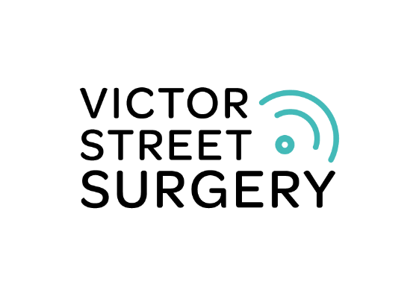

Allied Health Professional - Paramedic

Overview of Role & Main Duties
We are looking for an experienced Paramedic to work between 4 – 6 sessions per week at our excellent practice.
You will work as an autonomous practitioner, responsible for the delivery of practice services, working as part of the practice multidisciplinary team, delivering care within your scope of practice to the entitled patient population. You will be responsible for a number of clinical areas such as minor illness, health promotion, chronic disease management, health prevention, well women and well man clinics and carrying out home visits, as well as supporting the management team in the reviewing of clinical policy and procedure.
You will ensure care is seamless for our patients, and that everyone involved is working together, providing the capacity and expertise to support patients to engage with their health needs to make positive change.
Clinical Responsibilities:
The successful candidate will be expected to undertake a variety of duties including surgery consultations, telephone consultations and queries, visiting patients at home, checking and signing repeat prescriptions and dealing with queries, paperwork and correspondence in a timely fashion. However, the practice is currently investigating and trialling alternative working methods to reduce the administrative burden place upon GPs and ANPs and AHPs with today’s demands. You will therefore feel well supported and your workload will be well balanced.
Job Description
The following are the core responsibilities of the Paramedic. There may be on occasion, a requirement to carry out other tasks; this will be dependent upon factors such as workload and staffing levels:
A paramedic will:

- Work as part of a multi-disciplinary team (MDT) within Victor Street Surgery

- Assess and triage patients, including same day triage, and as
appropriate provide definitive treatment (including prescribing
medications following policy, patient group directives, NICE (national)
and local clinical guidelines and local care pathways) or make necessary
referrals to other members of the primary care team

- Advise patients on general healthcare and promote self-management where appropriate, including signposting patients to the organisation’s social prescribing service and, where appropriate, other community or voluntary services

- Be able to:

- Perform specialist health checks and reviews within their scope of
practice and in line with local and national guidance

- Perform and interpret ECGs

- Perform investigatory procedures as required and undertake the collection of pathological specimens including intravenous blood samples, swabs and other samples within their scope of practice and within line of local and national guidance

- Support the delivery of ‘anticipatory care plans’ and lead certain services (e.g., monitoring blood pressure and diabetes risk of elderly patients)

- Provide an alternative model to urgent and same day GP home visit for the practice

- Communicate at all levels across organisations ensuring that an effective, person-centred service is delivered

- Communicate proactively and effectively with all colleagues across the MDT, attending and contributing to meetings as required

- Maintain accurate and contemporaneous health records appropriate to the consultation, ensuring accurate completion of all necessary documentation associated with patient healthcare and registration with the organisation

- Communicate effectively with patients and, where appropriate, family members and their carers, where applicable, complex and sensitive information regarding their physical health needs, results, findings and treatment choices

Supervision and Support
As an Allied Health Professional and member of our team, you will have:
- Line Management supervision and support on a day-to-day basis from a Clinical Lead and GP Partner
- Access to support and wellbeing services available

Overview of Victor Street

We serve a community of 12,200 people in the West of Southampton in an urban area, and pride ourselves in delivering patient-first care alongside ambitious and innovative clinical and strategic leadership. We drive changes from the front: we have a Clinical Director for our PCN, a GP trainer, an LMC rep, and a non-clinical Partner shaping strategy and development.
Our clinical team consists of 6 GPs, 2 Advanced Nurse Practitioners who deliver a mix of same day and long-term condition care, and do our acute home visits, and an excellent Practice Nursing Team who take the lead on managing long term conditions.
Our team is ever expanding through the support of the PCN. We have Social Prescribing link workers, first contact physiotherapy, a clinical pharmacist, a primary care mental health nurse and peer support workers, and a dedicated Enhanced Health to Care Homes team working alongside us. We are supported by reception Care Navigators, an administration team who deliver workflow optimisation, and by a strong senior management team.
- 12,200 patients
- Urban inner-city area, on the boundary of the New Forest national park
- SystmOne, supported by Ardens and AccuRx
- Supported by a strong city-wide GP Federation who are delivering Covid Hot Services (face to face, remote CO@Home sats monitoring, “hot” home visits)
- Remote working well established for telephone triage, video consultations and eConsultation
- Keen MS Teams users to ensure we continue connecting with our community MDT and educational meetings
- Daily “down tools” tea break for clinical team to recharge and chat

We are a values-based Partnership, focusing on building health for the whole team as well as our patients. We see the importance of celebrating and listening to every member of the team, in order to develop a positive culture and nurture strong relationships that leave our staff feeling valued.
We do this by cultivating an environment where we can each:
Be Healthy
We understand the fundamental importance of health and wellbeing, both as individuals and as a group. Optimal health is a collective effort, and through close support and teamwork, we aim to create a working environment where every member of the team is as healthy as they can be.
Be Ambitious
We are committed to developing and realising our own potential and the potential of others. Every day, we bring an enthusiasm and determination to evolve, both professionally and personally. We come to work with a strong conviction that as a team we can achieve excellent results.
Be Collaborative
We believe that teamwork is essential. Every member of our team is valued, both for the attributes they bring to the job and for who they are as a person. Beyond our team, we are dedicated to our patients and the wider community, collaborating to create a healthier Southampton for everyone.

Be Open
We work in a transparent, inclusive environment in which we seek out and encourage alternative perspectives. From fellow team members to our patients and the wider community, we treat everyone with empathy and respect, taking an honest, non-judgemental approach to every interaction.

Apply
Salary is competitive and dependent on experience.
We are a training practice and able to provide excellent mentorship and clinical support

If you want to see transformation that improves lives city-wide, you can do that work here.
Join our team today.
Please send a copy of your CV and covering letter to Mr Craig Stanley, Practice Business Manager at craig.stanley@nhs.net
We would encourage and welcome informal conversations at any time.

Employer Details:
Victor Street Surgery, Victor Street, Southampton, SO15 5SY
W: https://www.victorstreetsurgery.nhs.uk/
E: craig.stanley@nhs.net

Closing date: 31st March 2023
The practice reserves the right to close the advert early should a suitable candidate be selected prior to the closing date.

