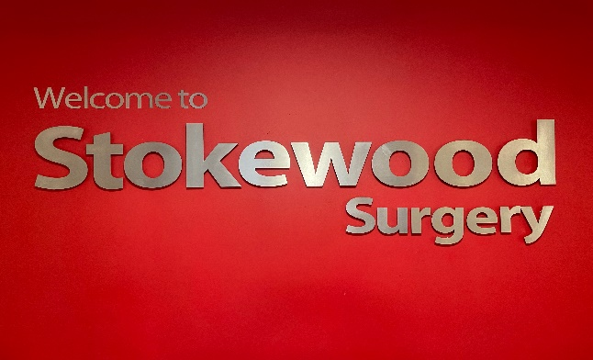

Maternity Locum (from July/August 2023)
Stokewood Surgery, Fair Oak, Eastleigh, Hants

Stokewood Surgery is looking for a locum GP from August 2023 to cover 6 sessions per week. Ideally we are looking for the locum to cover the full 12 months but would consider other options including job share. We are looking for a GP who would be willing to take on the admin and fair share of visits and duty sessions. Up to £11,500 per session to include pension.

The Practice is located in Fair Oak, within the Borough of Eastleigh, a commutable distance from Winchester, Southampton and Romsey, close to the edge of the South Downs, with easy access to the coast and New Forest.

More about our Practice:
- 15 minute appointments
- 14 appointments per session with no extras
- 6 weeks annual leave and one week study leave pro rata
- All rooms equipped with dual screens
- We use EMIS web, eConsult, Docman and ICE
- Document workflow screening reduces GP letters significantly
- Team of 5 partners and 8 salaried GPs, 2 Advanced Nurse Practitioners, paramedic, MSK physios, clinical pharmacist, a team of practice nurses and healthcare assistants, plus supportive reception and administrative staff members.
- Current list size of 19,200 patients.
- Branch site located 1.5 miles away.
- CQC Rated Good (August 2020)
- In-house Education programme and mentorship, including programme of clinical, significant event and external speaker meetings
- We are a training practice with two registrars and medical students
- Research active practice, participating in several COVID trials
- PMS contract and extended hours access
- Member practice of the Winchester Rural South PCN

For more information, see website: Homepage - Stokewood Surgery

Facebook: (16) Stokewood Surgery | Eastleigh | Facebook

Please contact the practice manager for more details. Deborah.humphries@nhs.net

