**Assynt Medical Practice**

**GP Information Pack**

**Closing date 10th June 2023**

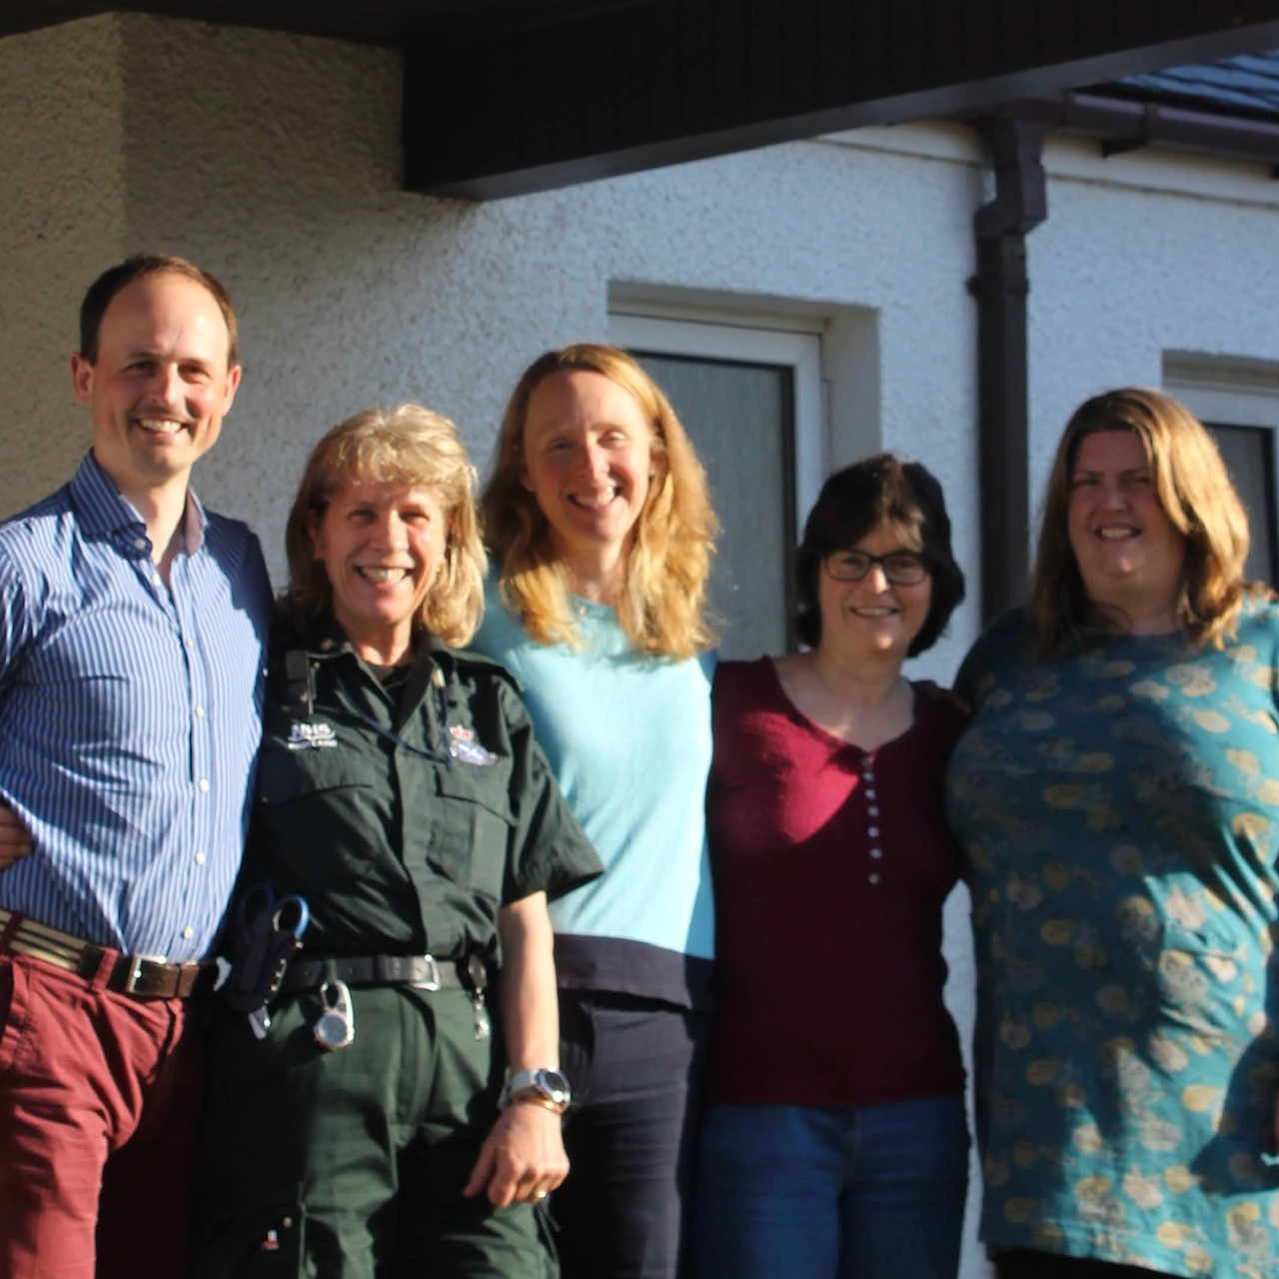

*(Our Clinicians)*

**Who are we?**

Assynt Medical Practice is a remote and rural Practice located in the picturesque coastal village of Lochinver, around two hours’ drive, North West of Inverness – Capital City of the Highlands – having good rail and flight connections. The current patient list size is 1000 and is boosted by 250 temporary patients each year.

We strive to provide realistic, holistic family medicine to our rural population whilst retaining a healthy balance between work and life. Supporting an ethos of mentoring and of supporting staff to develop their qualifications and expand their role. We believe that any organisation is only as good as the people working within it. We pride ourselves on being an inclusive “people based” organisation where all staff are valued for their contribution to the Practice as a whole.

Our Practice team is stable - many of us have been here for a long time - and staff turnover tends to be caused by retirement.

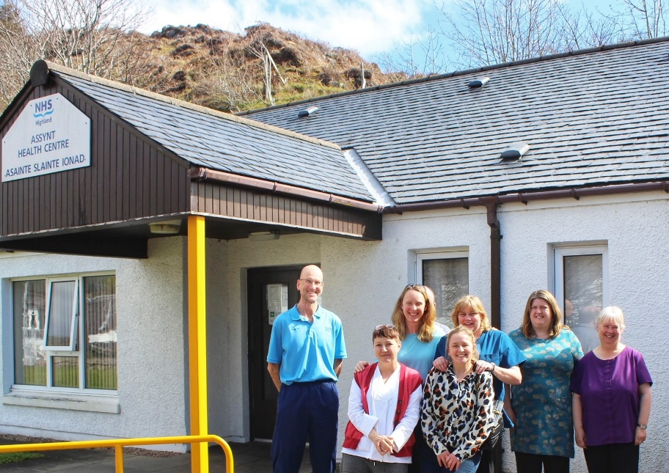

*(Part of the Clinical, physiotherapy and administrative teams)*

# **Clinicians**

GPs

Partners/Salaried

* Dr Fiona Hamilton, part time (7 sessions)
* Dr Sarah Donald, part time (5 sessions)
* Dr Isla Hislop, part time (5 sessions)

Health Care Assistant

* Rhona Macaskill, specialising in chronic disease monitoring/health promotion/phlebotomy

Community Nursing Team

* Charlotte Appleby – District Nursing Lead for West Sutherland
* Wendy Wright

# **Management**

# 

Practice Manager

* Kenneth Kerr

The Practice Manager is responsible for the day to day running of the Practice. They also have a role in the strategic development, financial planning and business development of the Practice.

# **Reception & Administrative Support**

We have an experienced office staff comprising five members of staff covering reception, administrative and dispensing duties. Most of our office staff have been with us for many years and offer a wealth of local knowledge.

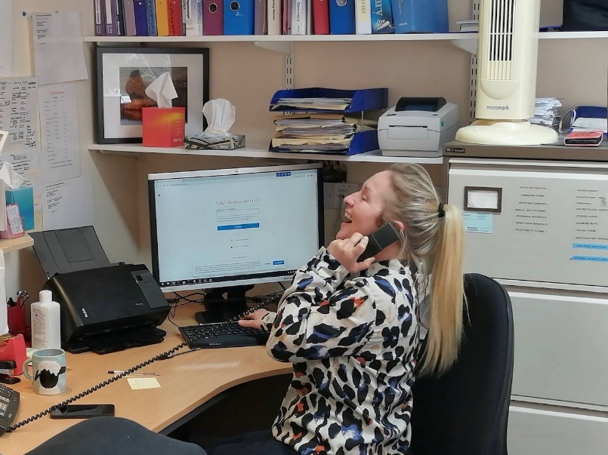

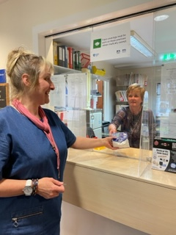

***(****Despensing and reception)*

**Attached staff**

Our area is lucky to have a fabulous District Nursing Team, Community Mental Health Team, Occupational Therapist, First Contact Physiotherapist and Community Dental Team. These colleagues work in the same Practice building making team working and communication easy - we have weekly nursing meetings and monthly Multi-Disciplinary Team meetings (MDTs).

The Practice is also supported by other NHS services including a Health Visitor/School Nurse, Midwifery service, Social Services, chiropodist, dietician and visiting Consultants such as Psychiatrists, Physician for the Elderly and Cardiology.

**Where are we?**

We live and work in a rural area with some geographically remote places. Our population, like much of rural Scotland, is generally an ageing one, with geographical and social isolation as one of its main challenges.

Our Practice area extends from Kylestrome in the north, the Benmore estate to the east and Drumrunie to the south. The sprawling nature of the Practice area presents a unique set of challenges to the provision of safe, effective healthcare.

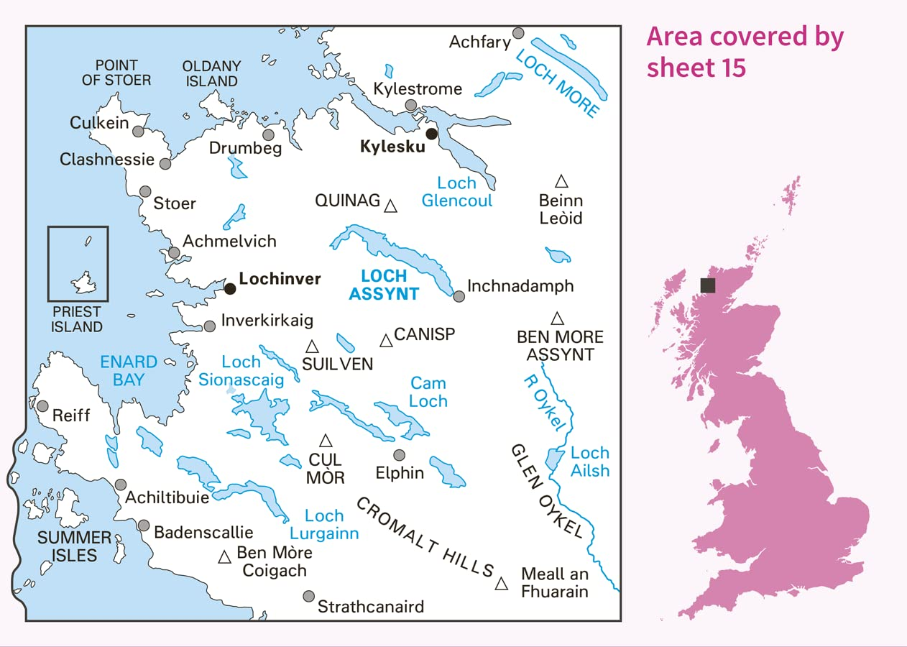

*(Map covering the practice area)*

Our neighbouring Practices are to the north, Scourie/Kinlochbervie/Durness, to the south, Ullapool and to the east, Lairg Practice.

**What is it like to work here?**

***Our ethos is to provide care to patients as close to their own homes as is safe and practical, by the right person at the right time.***

Our working day starts at 09.00 (apart from the duty doctor who is on call from 08.00).

Our morning session comprises of 9 appointments (combination of telephone and face-to-face, Near Me is available on request too) along with time for emergencies and administrative matters. We all break for coffee around 11.30am. Afternoon sessions are similar in arrangement, starting at either 3-5pm or 4-6pm.

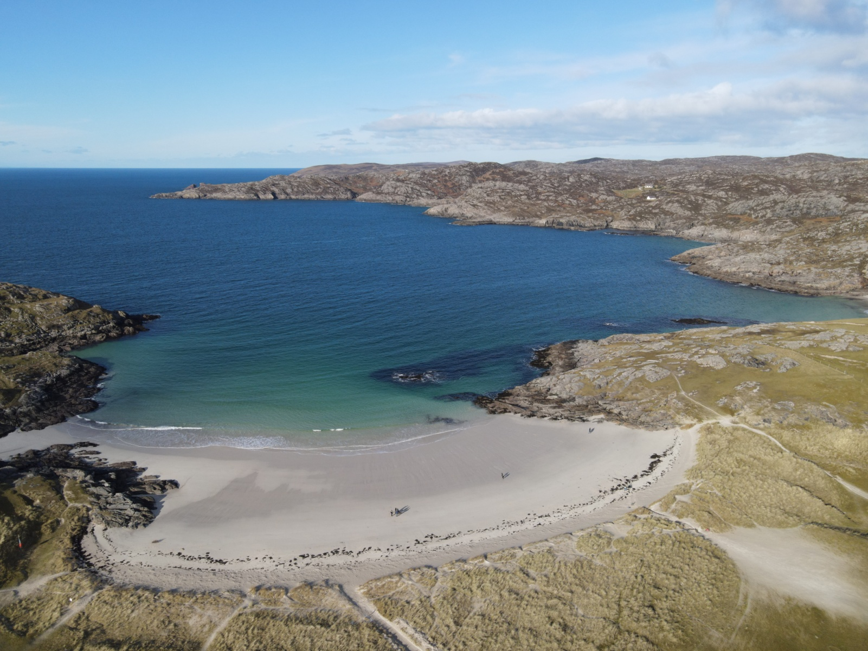

*(Clachtoll beach)*

Docman and Daybook tasks (repeat medication requests, medical reports) are shared between the clinicians on duty that day, we aim to deal with today’s work today where possible. We encourage a healthy work/life balance and try hard to ensure that we can leave on time.



*(Stac Pollaidh)*

There is no routine Friday afternoon surgery but the surgery remains open and the doctor is available for urgent clinical matters, handing over to the weekend OOH GP, employed by NHS Highland, at 6pm.

**Out of hours**

We are no longer responsible for providing weekend on-call cover – this is provided by dedicated OOH GPs based in Kinlochbervie and Ullapool, employed by NHS Highland. We continue to cover the on-call work through the week from 8am Monday through ‘til handover at 6pm on Friday.

We work collaboratively with the Scottish Ambulance Service, our community nursing team and the OOH clinical cover for the wider area.

*(Some of the impressive Assynt Mountains)*

**How do we perceive ourselves?**

The Practice is forward thinking and committed to developing the whole Primary Health Care Team to deliver a high quality and cost effective service to our patients. Furthermore, to provide a professional yet informal supportive environment, in which all team members are valued and encouraged.

*“All staff based at the Assynt Medical Practice are warm, friendly and promote professionalism; they work collaboratively and are passionate in the care of their patients”*

*“I find the unique and diverse environment of Assynt and Lochinver, hugely enhances person-centred care and provides an opportunity to forge excellent professional relationships with all staff”*

(*Mairi Mackay, Community Psychiatric Nurse*)

**Areas of Achievement**

* Over the last 5 years we have worked closely with our Community Nursing Team and Health Care Assistant to carry out triage, home visits, acute appointments and chronic disease monitoring in as seamless a manner as possible to enable best patient care depending on which clinician is available at the time needed.
* Consistently achieved high scores in patient satisfaction survey.
* Invested in a programme of mentoring and training sessions for the benefit of the whole team.
* Improved patient access by telephone/Near Me.
* Been assessed and certified by the Ministry of Defence (MoD) and the General Medical Council (GMC) as a training practice for MoD GP trainees. We now host GP trainees from the combined forces for 3 month placements.
* Developed regular 6 weekly MDT online meetings with a Consultant for Care of the Elderly and a Cardiologist, which is both educational for the wider clinical team and reduces the need for unnecessary patient travel.
* Continue to host and expand our Medical student and FY2 ‘taster’ placements from across the UK and abroad for electives.
* Reduced dependency on paper through achieving ‘paperless ’status.
* Maintained involvement with the North and West Operational Unit and the Sutherland Small Surgery Cluster.
* Represented the North and West and remote/rural GP Practices on the Local Medical Committee (LMC Highland) and the GP Subcommittee for the Highland region.

Other recent innovations include; performing iron infusions for our patients, obtaining and using a bladder scanner, taking part in a ‘pill-cam’ pilot, encouraging more consultants to come to our Practice to operate outreach clinics or tele-health appointments.

**Services provided**

The Practice provides a full range of ‘Essential ’and ‘Additional ’services as required by the GMS Contract. In addition, we also offer;

|  |  |
| --- | --- |
|  |  |
| GP led | Health Care Assistant led |
| Minor Injury  Minor Surgery  Mental Health  Sexual Health  Anticipatory Care  Palliative Care  Contraceptive Implant IUCD  (contraceptive coil)  Polypharmacy  Immediate Care  Cervical Cytology  Venesections  Iron Infusions | COPD (obstructive airways disease)  Diabetes Management  Hypertension Management  Health Promotion  Asthma  Near Patient Testing  INR(anti-coagulation/warfarin  monitoring) Phlebotomy  Treatment room services |



*(Clashnessie beach)*

# **Clinical Governance**

# 

The Practice places great importance on working with other agencies and healthcare professionals, and to this end we facilitate and encourage informal communication as well as collaboration in more formal settings. We hold regular meetings in order to maintain effective communication and promote information sharing.

**GP/Practice Manager Meetings**

Monthly - attended by Partners, Practice Manager and Business Consultant

**Practice Meetings**

2 monthly - attended by all Partners and staff

**Clinical Meetings**

Weekly - Regular meetings attended by Partners, Salaried GP, Community Nurses, Health Care Assistant, Community Psychiatric Nursing Team.

**MDT/Cancer/Palliative Care Meetings**

Monthly - attended by a GP, District Nurse, MacMillan Nurse, Social Work, Local Community Care Manager ([www.communitycareassynt.org.uk](http://www.communitycareassynt.org.uk/)).

**What ’s it like to live here?**

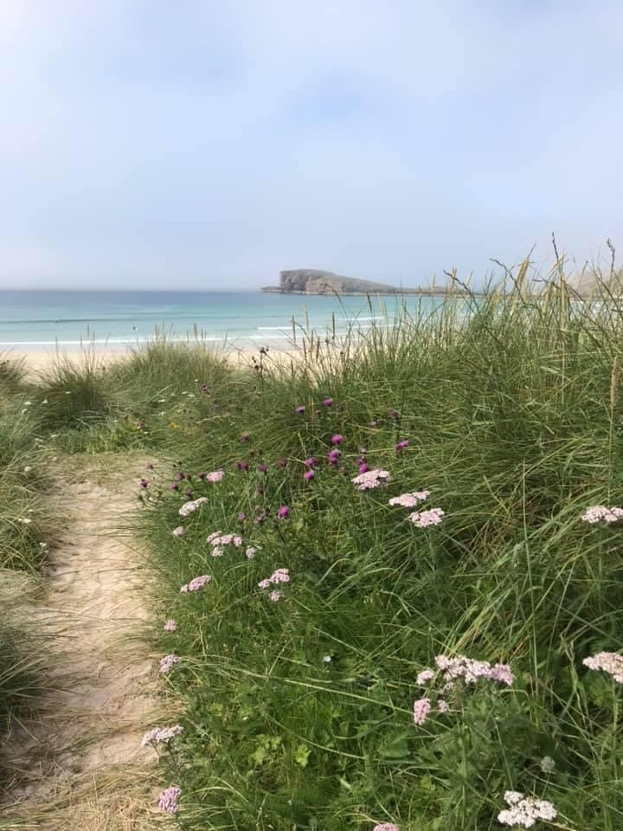

*(Widows Falls) (Alchmelvich beach)*

The small fishing port and village of Lochinver on the North West coast of Scotland offers incredible mountain views, white sandy beaches, unique wildlife and legendary tasty pies.

Sitting on a sheltered bay north of Ullapool and on the North Coast 500 iconic route, the town makes a great base for exploring the hidden gems and spectacular scenery of the North West Highlands Geopark.

Inverness, Capital City of the Highlands is 97miles south east and Ullapool 37miles south.

Lochinver attracts some of the UK’s biggest names to its Highland Games, held in August every year ([www.assynthighlandgames.co.uk](http://www.assynthighlandgames.co.uk/)).

Lochinver boasts some excellent eateries including the Award Winning Lochinver Larder ([www.lochinverlarder.com](http://www.lochinverlarder.com/)), Delilahs ([www.delilahs.co.uk](http://www.delilahs.co.uk/)), Peets Restaurant ([www.peets.co.uk](http://www.peets.co.uk/)), The Culag Hotel ([www.culaghotel.co.uk](http://www.culaghotel.co.uk/)) and The Inver Lodge Hotel (www.inverlodge.com).

Lochinver is well provided for by a Spar supermarket, Newsagent, Post Office and small independent grocers and butchers, two cafes and a selection of various other shops.

Tourism is the main industry with several hotels, guesthouses and B+B’s. There is also a thriving pottery (Highland Stoneware Pottery - [www.highlandstoneware.com](http://www.highlandstoneware.com/)) which sells unique and beautiful ceramics all crafted by hand by local artists.

In Lochinver there is a small, vibrant primary school that regularly combines learning with adventures such as kayaking on the loch beside the school or activities in the community woodland. The Primary School was recently assessed as ‘Good’ by the Highland Council 20/12/22 (http://lochinverprimary.wordpress.com). There is an excellent high school in nearby Ullapool with transport provided (<http://www.ullapoolhigh.highland.sch.uk/>).

We have our own community Leisure Centre ([www.assyntleisure.co.uk](http://www.assyntleisure.co.uk/)) offering gym and hall facilities and exercise classes with regular bowling/badminton and yoga sessions.

There is a community library in Ullapool and mobile visiting library to Lochinver every 3 weeks. The Lochinver Village Hall regularly hosts touring plays/musicians and concerts, not to mention weekly craft and produce markets – [www.madeinassynt.co.uk](http://www.madeinassynt.co.uk/), [www.discoverassynt.co.uk](http://www.discoverassynt.co.uk/)

There is a strong community spirit: the first community land purchase took place here in 1993 and others followed with pioneering land restoration projects ([www.theassyntcrofters.co.uk,www.assyntfoundation.scot](http://www.theassyntcrofters.co.uk,www.assyntfoundation.scot)).

There is both a community council and a community development trust with a variety of ongoing projects, including a bold modern housing development scheme ([http://www.assyntdevelopmenttrust.org](http://www.assyntdevelopmenttrust.org/)).

We have a busy harbour offering home to a small fishing fleet, seasonal boat tours, charters, pleasure crafts/yachts and a busy foreign fishing fleet that use the harbour for landing and handling their catch ([www.highland.gov.uk/info/1523/transport_and_streets/102/harbours/6](http://www.highland.gov.uk/info/1523/transport_and_streets/102/harbours/6)).

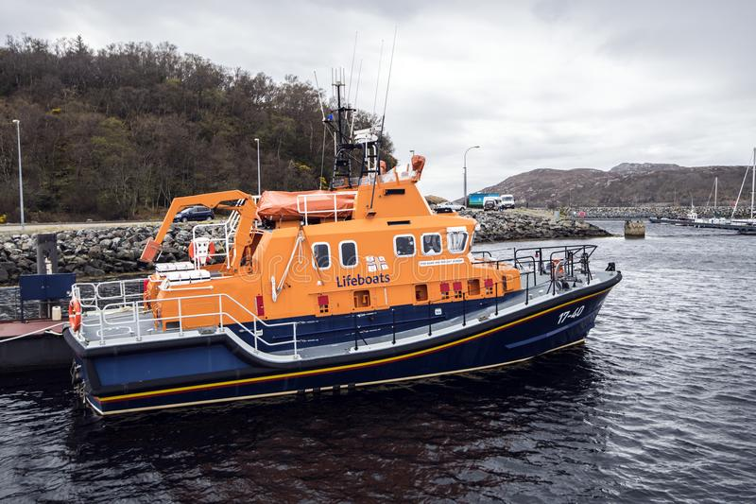 



We are lucky to live in an area of exceptional natural beauty with many opportunities to pursue outdoor pursuits.

 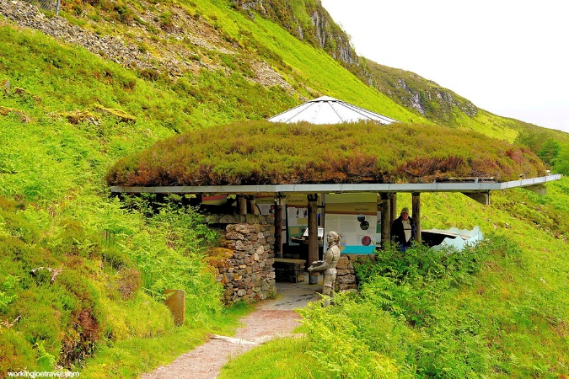

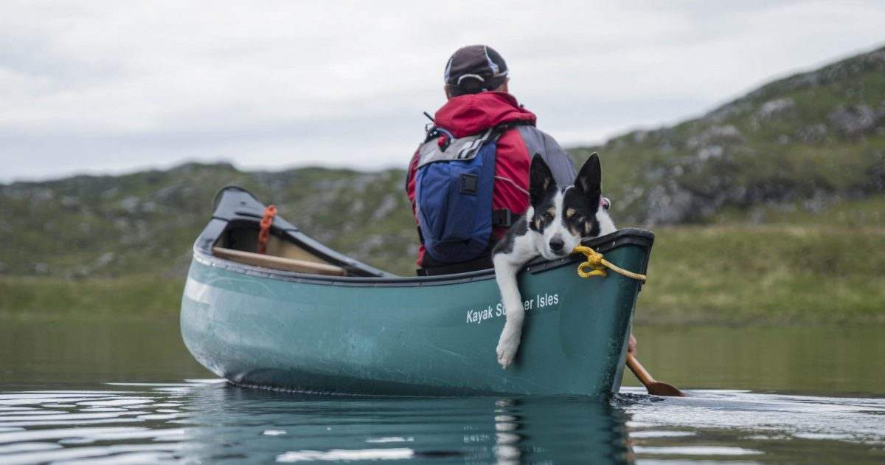

 

There are plenty of local clubs to join and there is a vibrant music and arts scene both in Lochinver and nearby Ullapool. There are also plenty of opportunities to become part of this friendly community through volunteering in local projects.

Links below for further information.

[www.assyntleisure.co.uk/clubs](http://www.assyntleisure.co.uk/clubs)

[www.summerislesseakayaking.com](http://www.summerislesseakayaking.com/)

[www.assyntmountainrescue.co.uk](http://www.assyntmountainrescue.co.uk/)

[www.hamletmountaineering.com/lochinver-climbing-festival](http://www.hamletmountaineering.com/lochinver-climbing-festival)

[http://www.antallasolais.org](http://www.antallasolais.org/)

www.facebook.com/LochinverFC

[www.bridgehouseart.co.uk](http://www.bridgehouseart.co.uk/)

[www.assyntwildlife.org.uk](http://www.assyntwildlife.org.uk/)

[www.culagwoods.org.uk](http://www.culagwoods.org.uk/)

To apply please post or email your CV and covering letter to:

Dr Sarah Donald (GP Partner)

Assynt Medical Practice

Lochinver

Lairg

IV27 4JZ

e: [sarah.donald@nhs.scot](mailto:sarah.donald@nhs.scot)

t:01571 844755

Alternatively, if you’d like to chat about the role or arrange a visit to the practice, please get in touch with Dr Sarah Donald, details above or:

Kenneth Kerr (Practice Manager)

e: [Kenneth.kerr@nhs.scot](mailto:Kenneth.kerr@nhs.scot)

t: 01571 844755

**Closing date for applications 10th June 2023**

ASSYNT MEDICAL PRACTICE

Job Description: Salaried GP

Responsible to: GP Partners (Clinical) and Practice Manager (Administrative)

**Person Specification summary**

The ideal candidate for this position will be committed to taking a holistic approach to high quality patient care. You will be an excellent communicator at all levels who appreciates the value of excellent team work. Additionally, you will take ownership of your own continued professional development and any clinical area of special interest which you would like to pursue and lead.

A good sense of humour and a friendly manner are essential.

**Job Specification summary**

The post holder will be responsible for providing safe, effective and efficient primary care medical services to patients of Assynt Medical Practice. To work with the Assynt Community team and associated services to ensure efficient and continuous quality improvements.

Key responsibilities:

Following Practice and NHS Highland policies, protocols and guidelines. Duties will include:

*Clinical*

1. Taking clinical responsibility for registered patients and maintaining appropriate records of treatment given and services provided following GMC guidance and good clinical practice.
2. Offer and carry out consultations and where appropriate, physical examinations for the purposes of identifying and reducing the risk of illness, disease or injury, including immediately necessary, emergency and temporary patients.
3. In accordance with the practice timetable the GP will make him/herself available to undertake a variety of duties including surgery consultations, telephone consultations, Duty doctor responsibilities, home visits, checking and signing prescriptions, dealing with queries and paperwork (including Docman) and correspondence in an efficient and timely manner.
4. Give advice to patients on general health matters including alcohol,

smoking, misuse of drugs etc.

5. Offer and provide immunisations as appropriate.

6. Arrange for the referral of patients, as appropriate using SCI-Gateway.

7. Provide family planning and contraceptive services advice.

8. Compiling and issue computer generated prescriptions in accordance

with the NHSH Formulary and guidelines whenever this is clinically

appropriate.

9. Dispense medication if dispenser not available and to do regular

Controlled Drug checks.

10. Carry out and review medication prescribing.

11. Participate in child health surveillance and child immunisation

Programme, when appropriate.

12. Provide maternity medical services and minor surgery services where

Appropriate and where the GP meets local eligibility criteria.

13. Actively participate/ cooperate in the management arrangements of

the practice and in the work of the primary healthcare team.

14. Participate in the effective and efficient management of chronic

diseases.

15. Maintain appropriate levels and means of communication with other

agencies with whom care is being given to the patient for whom the

practice is responsible.

16. Working supportively alongside clinical and administrative colleagues

in ensuring the highest standard of care for all Practice patients.

17. Maintain accurate, contemporaneous and correctly coded records to

relevant professional and practice standards and guidelines.

18. Participate in annual flu vaccination clinics and other as required

including potentially any Covid booster clinics if that becomes

necessary.

19. Carry out medical examinations and reports as necessary for both

occupational i.e DVLA/ML5 and personal e.g. Insurance Reports.

*Teaching and training*

1. Participate in the GP Appraisal and revalidation process.

2. Participate in educational and training events including where necessary TURAS.

3. If appropriate participate in teaching/mentoring.

1. Contribute to the development of the Assynt Medical Team and support the education of other team members.

*Communication*

1. Communicate effectively with clinical and non-clinical colleagues to

ensure the smooth running of the service.

1. Liaise with members of the primary health care team, integrated team,

hospitals and other agencies to ensure appropriate care is provided to patients.

1. Communicate effectively with patients and carers, recognising their

needs for alternative methods of communication.

1. Demonstrate sensitive communication styles to ensure patients are

fully informed and consent to treatment.

1. Communicate difficult and often unpleasant or sensitive messages to

Patient’s and families.

1. Participate in meetings as required.

*Organisation and Quality*

1. Recognise and work within own competence and the professional code

of conduct for doctors as set out by the GMC.

1. Must be included on NHSH Performers list and registered with the

GMC. Must be a member of a recognised medical defence society.

1. Follow NHSH policies including Security and Information

Governance.

1. Deliver administrative tasks promptly and efficiently.

1. Prioritise and manage own and others workload in a manner that

maintains and promotes high service and quality standards to ensure

effective time management within the team.

1. Deliver care to local and national standards including SIGN Guidelines,

GMS contract guidance, Highland Formulary, Highland Shared Clinical Guidelines and evidence based care.

1. Evaluate the quality of the work of self and team, using the audit cycle

when appropriate and implementing improvements where required.

1. Participate in quality improvement initiatives, including Highland

Quality Approach, Scottish Patient Safety Programme – Primary Care initiatives, Significant Event Analysis, peer review and review of complaints. Cooperate fully and openly with the investigation of patient complaints (or other investigations) including drafting responses to complaints as appropriate.

1. Support and work towards the achievement of national and local

Standards.

10.Support the aims and objectives of the organisation and contribute

to the ongoing development of the service as required.

*Teamwork*

1. Work as an effective and responsible team member, supporting other members of clinical and non-clinical staff in a flexible and approachable manner.
2. Understand own role and scope within the organisation and identify

how this may develop over time.

1. Participate in team activities that create opportunities to improve patient care.

4. Lead or participate in projects or areas of work as required.

*Information Technology*

1. Review, enter and process data using accurate Read codes and good

record structure in order to ensure easy and accurate information retrieval for monitoring, financial and audit processes.

1. Timely assessment of incoming electronic and paper correspondence

relating to patient and non-patient information as required using DOCMAN, VISION, GP2GP.

1. Understand and follow the requirements of confidentiality (including

the Data Protection Act) and the Freedom of Information Act and to refer on any queries as appropriate.

1. Follow individual practice and NHSH policy regarding the use of email

and computer tasks as the main internal method of non-verbal communication and the use of the intranet and internet as the main source of internal and external information, including the retrieval of relevant information for patients on their condition.

1. Maintain knowledge and skills in the use of technology including Vision and Docman.

*Equality and Diversity*

1. Act as a role model in the observance of equality and diversity good

Practice.

1. Act in a way that recognise the importance of people’s rights,

interpreting them in a way that is consistent with procedures.

1. Respect the privacy, dignity and beliefs of patients, carers, visitors and

co-workers. They must be treated equally irrespective of gender, ethnic origin, age, disability, sexual orientation, religion etc.

1. Follow the NHSH chaperoning policy.

1. Be aware of statutory procedures, local guidance and referral criteria

regarding protection of children and vulnerable adults. Follow the

guidance and policies and take action in an appropriate manner.

*Health, Safety and security*

1. Apply infection control measures according to local and national

Guidelines.

2. Use the personal security systems according to guidelines.

1. Follow health and safety policies and guidelines, including fire

procedures and those pertaining to clinical areas of risk. Use safe working procedures and report incidents using the DATIX system.

1. Monitor work areas and practices to ensure they are safe and free from hazards and conform to health, safety and security legislation, policies, procedures and guidelines.

*Other*

1. Give good and regular attendance.
2. Maintain a tidy and organised work areas.
3. Any other duties as requested, including covering for absent

colleagues.

To apply please post or email your CV and covering letter to:

Dr Sarah Donald (GP Partner)

Assynt Medical Practice

Lochinver

Lairg

IV27 4JZ

e: [sarah.donald@nhs.scot](mailto:sarah.donald@nhs.scot)

t:01571 844755

Alternatively, if you’d like to chat about the role or arrange a visit to the practice, please get in touch with Dr Sarah Donald, details above or:

Kenneth Kerr (Practice Manager)

e: [Kenneth.kerr@nhs.scot](mailto:Kenneth.kerr@nhs.scot)

t: 01571 844755

**Closing date for applications 10th June 2023**