**THE BRIDGE GROUP PRACTICE,HULL**

[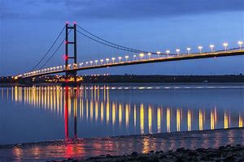](https://www.bing.com/images/search?view=detailV2&ccid=psHVGJWE&id=5BFF940FA94D13805156EE4907F4CA4846216699&thid=OIP.psHVGJWEf8elvGIXOi39vwHaE8&mediaurl=https://blueprintfilm.co.uk/wp-content/uploads/2017/03/humber_bridge_by_garona-d64aqdx-1.jpg&exph=683&expw=1024&q=humber+bridge&simid=608041271179348720&selectedIndex=5)

**(The Humber Bridge)**

**We are looking for a G.P. - six/eight sessions per week**

**We are a well-established four partner family practice, with an experienced practice team and we look on this as an opportunity to welcome a new colleague.**

**Based in two purpose built health centres, one in the north of the city and the other in the old fishing area of Hessle Road, we serve a population of around 9000.**

[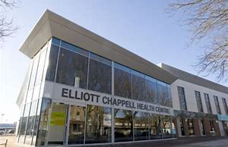](https://www.bing.com/images/search?view=detailV2&ccid=UjXmIPpB&id=7550CC39C8883F71FBE3861B3BCD6F0FCEE12AF1&thid=OIP.UjXmIPpBlpywZR-Se77eHgHaE8&mediaurl=http://www.thebridgegrouppractice.nhs.uk/images/Elliott%20Chappell%20Health%20Centre0655R.jpg&exph=400&expw=600&q=elliott+chappell+hull&simid=607995997936945217&selectedIndex=2) 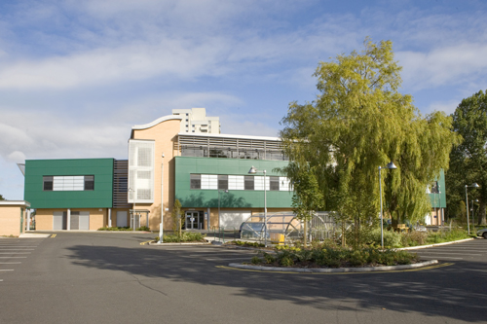

**We have an Advanced Nurse Prescriber two days per week. In addition we have two highly motivated and experienced nurses who, along with our two health care assistants take care of much of our long term conditions monitoring. The practice is fortunate in having excellent administration and reception staff at both sites**

**We are a GMS practice. Our clinical software is Systm One and we are paper light. We achieve highly in QOF and provide a range of Enhanced Services. Our C.Q.C. inspection in 2016 was rated ‘GOOD’ but, our main strengths lie in our commitment to the ideals of a traditional family practice with strong ties in our local population and good working relationship with our neighbouring practices**. **We are part of the well-established Hull GP Collaborative, comprising of 9 local practices.**

**Hull, the only maritime city in Yorkshire, has benefited from being the “City of Culture 2017”. It is a lively and quirky place and is surrounded by beautiful countryside- the Yorkshire Wolds to the west and north and spectacular cliffs and beaches to the East. It is also within easy reach of the Dales and North Yorkshire Moors**

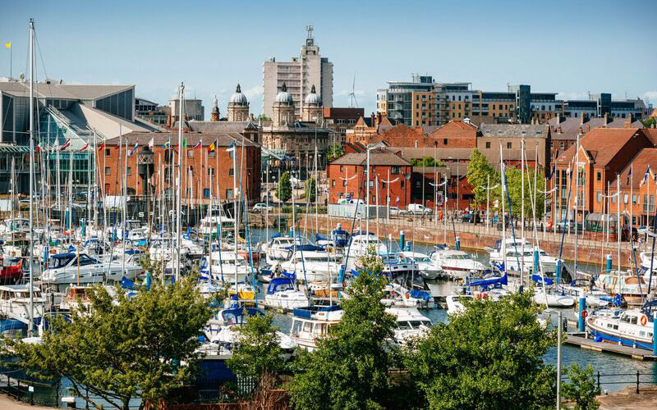  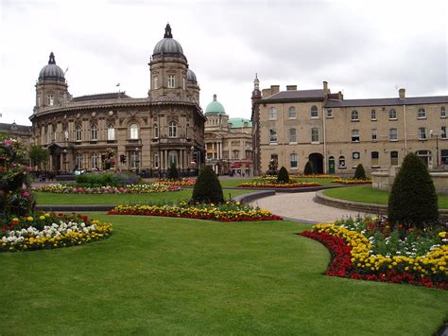 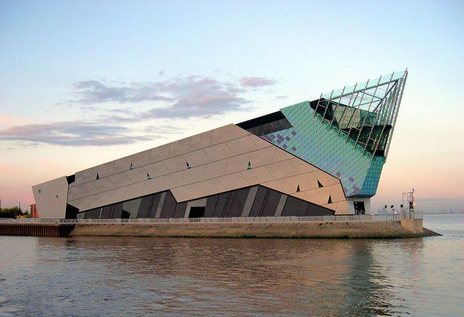

**(Hull Marina) (Hull’s Very Own Banksy) (Hull’s Queens Gardens) (The Deep – Hull’s Aquarium)**

**Theatre and concert goers are provided for with well-established major theatres, a thriving music scene and a major new concert venue has recently opened.**

**Rail links to York, Leeds and Sheffield are frequent and there are direct trains to London.**

**There are excellent residential areas in Hull itself but also easily commutable from nearby Beverley, the villages of West Hull and Holderness.**

**If you feel you would like to meet us and chat through what we have to offer you and how you could help us to develop our Practice, please contact Elaine Harrison Practice Manager (**[**elaine.harrison3@nhs.net**](mailto:elaine.harrison3@nhs.net)**) or 01482 857190.**

**Closing Date: Monday 31st December 2018**

**Our practice website is:** [www.thebridgegrouppractice.nhs.uk/](http://www.thebridgegrouppractice.nhs.uk/)

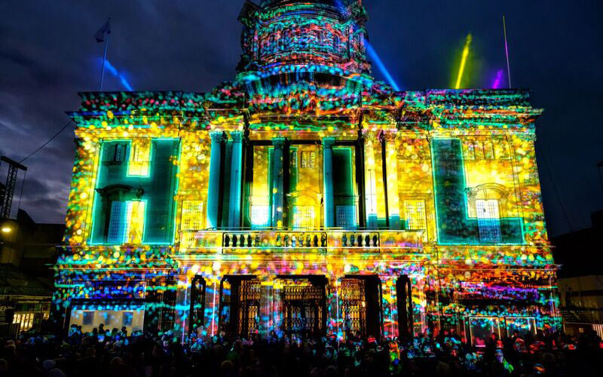

**(Hull’s City Hall)**