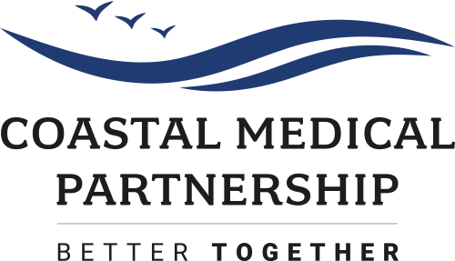

Salaried GP (with view to Partnership)
4-8 sessions per week
Starting date: March 2025

Coastal Medical Partnership is a forward thinking, merged partnership based across 5 sites in New Milton & Lymington. We have 21 GP Partners leading a clinical and non-clinical team, committed to providing high quality care for our 34,000 patients.

We have an exciting opportunity for a 4-8 session GP to join our dynamic, enthusiastic and well-regarded Practice close to the South Coast and the New Forest. We are a friendly, sociable team looking for another like-minded team member! We are looking for the right person to fit our team, and it is this that makes our session requirements flexible. We will try and fit our needs around the right person.

Across our partnership we have an extensive clinical team working alongside our GP Partners, striving to improve the health of our local population. The team includes Salaried GPs, GP Retainers and Nurse Practitioners; as well as a full complement of Treatment Room staff including Diabetes and Respiratory Specialist Nurses, highly trained Healthcare Assistants and Phlebotomists. This is supported by a robust and experienced team of Business Managers, Operations Managers, reception and admin staff.

As a single Primary Care Network, we are embracing the opportunities this has afforded us. We have successfully recruited a variety of the ARRS roles including Advanced Frailty Occupational Therapist, Pharmacists, Paramedics, Physicians Associates, MSK Practitioners, a range of care co-ordinators, and Health and Well-being Coaches who work within our GP-led Mental Health and Well-being team. We are using these Network funded roles to build teams within our Partnership to enhance the care we deliver, including an in-house Care Home Assessment Team who recently won Highly Commended for the Primary Care Innovation of the Year at the HSJ Patient Safety Awards 2024.

We strongly support the areas of special interest which our GPs have. These include areas used within our Partnership such as Minor Surgery, Contraception, Paediatrics, Research and Acupuncture, but many of our GPs also hold other GPwER roles such as GP Appraisers, Research, Mentoring, Frailty or Community Diabetes.

As a practice we are passionate about the education and training of all health professionals. We have many GP Trainers, GP Clinical Supervisors and Nurse Mentors within our team and support GP training and medical students, as well as Nursing, Paramedic and overseas students.

Come and join a young and dynamic group of GPs as we grow into a Modern General Practice fit for the 21st century. We are a work family who are committed to looking after each other as well as our patients, and this extends outside of the work place, participating in local charity events and regular social activities.

If this sounds like a team you’d like to be part of, please email a CV and covering letter. If you would like to find out more or arrange to visit the practice please contact our Business Managers, Matt Perkins and Kelly Anderson. Please note we hold a Tier 2 sponsorship licence so welcome applications from GPs requiring a Certificate of Sponsorship.

Contact email: matt.perkins@nhs.net / kellyanderson@nhs.net
Contact phone: 01425 201074

