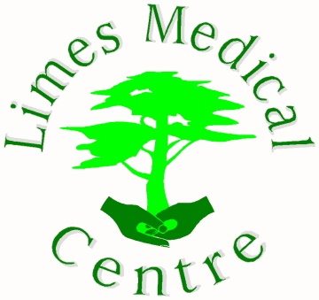

Practice Partners:

Dr J Southcott

Dr A Bright

Dr D Pontefract

Limes Medical Centre

Limes Avenue

Alfreton

Derbyshire

DE55 7DW

Tel No: 01773 833133

___________________________________________________________________________

**Salaried GP Opportunity**

**Four and Six sessions, Tier 2 visa sponsorship available**

**£11*1,500 per session**

**GP training practice**

An opportunity has arisen for two GPs to join Limes Medical Centre.

A four-session post Thursday, Friday (AM & PM) and a newly created six-session post, Tuesday, Wednesday, and Friday (AM & PM)

We are looking for an enthusiastic and driven individual to join our forward thinking and supportive team.

The practice has a strong focus on continuous development and improvement at all levels.

Limes Medical Centre is a friendly, supportive, and forward-thinking practice located within easy access of the Peak District, cities of Derby and Nottingham.

Limes Medical Centre have a wide-ranging skill mix to include GP Partners, Salaried GPs, Practice Manager, Practice Nurses, HCAs, and a full administrative support team.

We work closely within our PCN (South Hardwick) working with a wealth of ARRS roles including First contact Physios, Pharmacists, Social Prescribers, and a Mental Health Practitioner.

Tier 2 Visa sponsorship available.

For further information or to arrange an informal visit to the Practice please call Nikki Stewart (Practice Manager) on 01773 833133 or email [nikki.stewart9@nhs.net](mailto:nikki.stewart9@nhs.net)

Information about the practice and the services we offer is available on our website: <https://www.limes-medicalcentre.co.uk> **please note a new website is currently in progress and may not be available at times.

Applications should be made via email to nikki.stewart9@nhs.net providing a CV and covering letter.