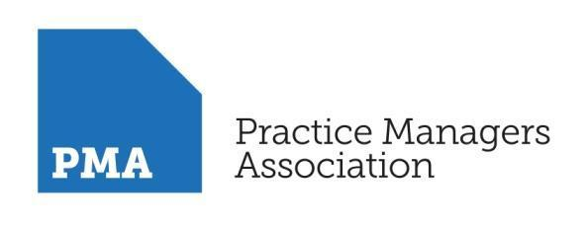

About the Facilitator
Paul Dodd
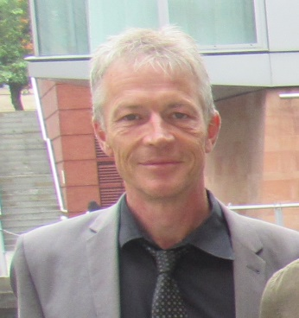

Paul has over 30 years’ experience of working in the National Health Service. Initially from an early career in nursing through to senior management.
In the year 2000 Paul moved to Stockport as a ward manager in orthopaedics, leaving a part clinical, part risk management role at Tameside but soon took a secondment with the NHS International Recruitment Team working between Stockport and various Educational and Healthcare Organisations across Spain. Setting up the first of several successful large-scale recruitment projects and appearing in a BBC documentary which followed one of these projects through Spain and back to Stockport as part of its ‘Trouble at the top’ series about Nurse shortages.
Moving back into the world of Risk Management, Paul has overseen the rollout of organisation risk management software systems, coordinated Trusts accreditation to various auditing bodies including the ‘NHS litigation authority’ and ‘CQC’, bringing and maintaining Trusts accreditation to the highest levels.
In recent years Paul has been working as the Head of Risk Management at Salford Royal contributing to the Risk and Governance elements of the Trusts CQC outstanding rating. Taking aspects of the Trusts Risk and Governance performance up to some of the best in the NHS. Extending his role to cover ‘Document Control’ and ‘Patient Information’, he again led the Trust to become one of the first to gain accreditation to the ‘Information Standard’.
A regular speaker at Salford University on Risk and Governance over the last few years, Paul has also run training courses and workshops extending across the whole health economy.
With recent experiences of being on the project group for the amalgamation of adult social care into the NHS and working across Salford with General Practitioners and community teams Paul brings a wealth of experience in Risk and governance across various sectors at senior management level.

